FIND THE 2 USE CASE OF M QUERY

CASE 1

Find Day of Year

**#"day_of_year" = Table.AddColumn(#"Changed Type", "DOY", each Date.DayOfYear([order_date]))**

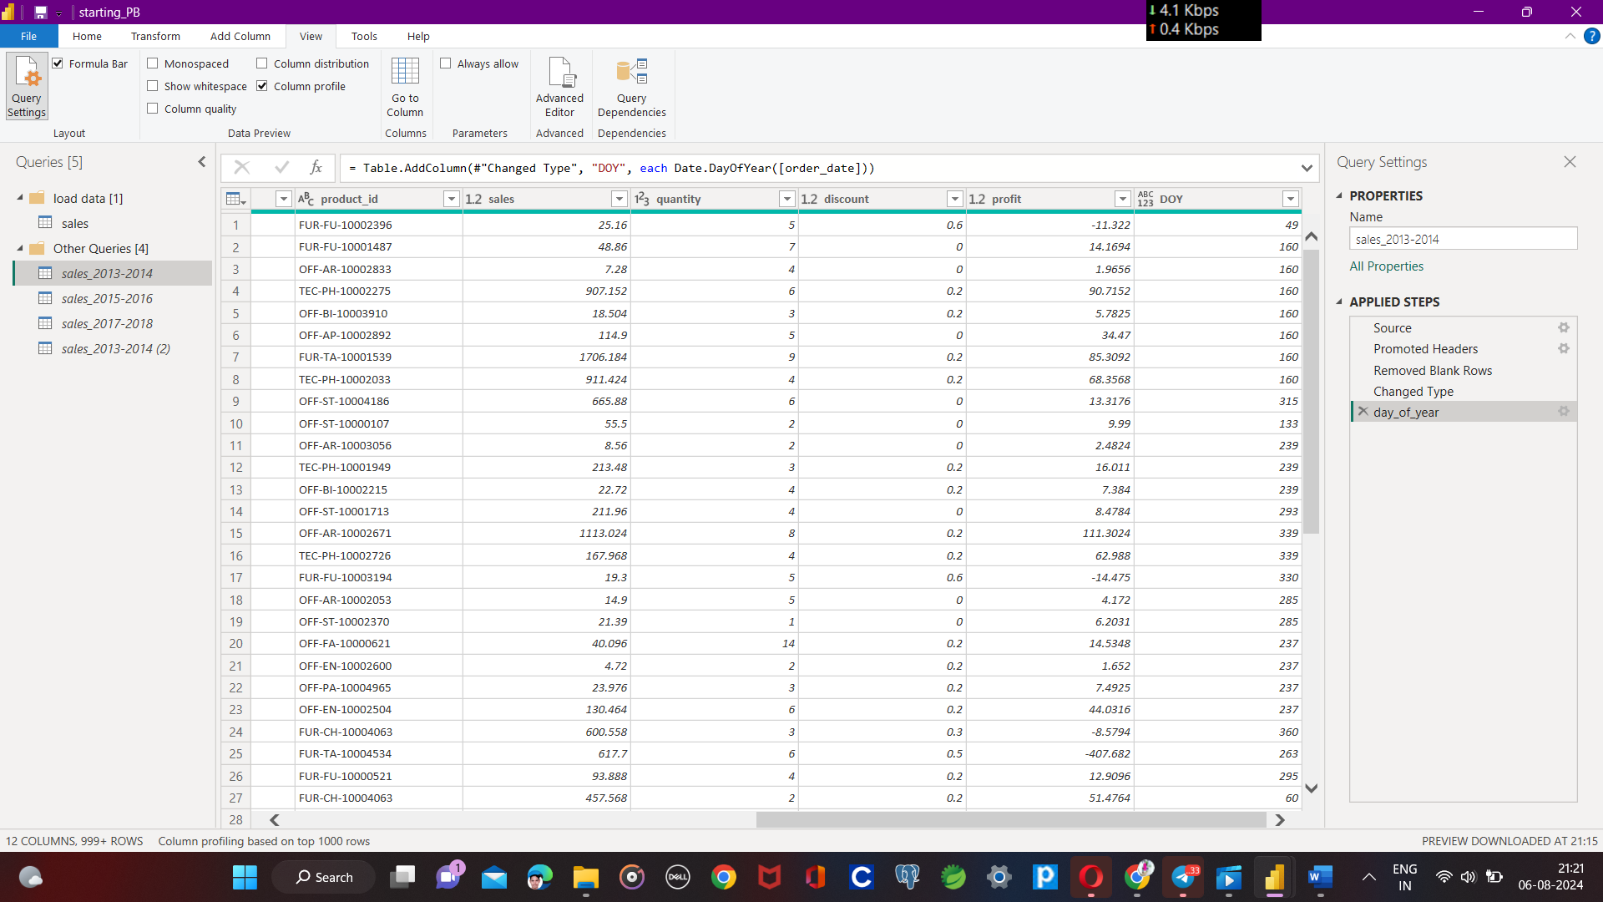

**2.**

CALCULATE DAY DIFFERENCE FROM SHIP_DATE TO ORDER_DATE

**#"Daystoship" = Table.AddColumn (#"day_of_year","daytoship",each Duration.Days([ship_date]-[order_date]))**

